5. Conflict of interest

Conflicts of interest can arise in a variety of constellations, when the interests of an individual or of his/her close personal relations diverge from those of the company or organization to which the individual belongs or belonged to.

Conflicts of interest can hinder the success of a company, lead to economic damages and also tarnish the company’s reputation if they become public, for instance, if the conflict of interest leads to uneconomical decisions, if customers get lost because they lose confidence in the integrity of the company or if confidential information is disclosed as a result. In some cases, conflicts of interest might also bear anti-corruption or antitrust risks.

To minimize risks related to conflicts of interest, every employee must comply with the following general principles:

|  |
| --- |
| General Principles:  Business decisions always have to be made in the best interest of the company and not on the basis of personal interests.  Situations, in which the appearance of a conflict of interest may arise, have to be anticipated and avoided. Avoiding a conflict of interest can also mean to abstain from decisions that could be affected by the conflict of interest.  Situations, in which the appearance of a conflict of interest may arise, have to be disclosed[1] to our managers. |

## 5.1. Typical constellations

There are typical constellations, in which a conflict of interest may potentially arise. In particular, such a conflict can be caused by:

* **Direct relationships of Siemens employees or external Business Partners[2]**,

i.e. Siemens employees or external Business Partners themselves, personally have:

* + Personal relations (A.5.1.1.).
  + Secondary/prior/subsequent employment in third party[3] companies (A.5.1.4.),

including job rotation between the public and the private sector (A.5.1.5.).

* + Competitive interest and/or investment in third party companies (A.5.1.2. und A.5.1.3.).
* **Indirect relationships of Siemens employees or external Business Partners**,

i.e. friends and/or family of Siemens employees or external Business Partners have:

* + Personal relations (A.5.1.1.).
  + Employment in third party companies (A.5.1.4).
  + Competitive interest and/or investment in third party companies (A.5.1.2. und A.5.1.3.).

By its nature, a conflict of interest may potentially arise not only to the detriment of Siemens but also for the benefit of Siemens. In both cases, the same rules apply.

In any case, especially if in doubt, please involve Compliance as early as possible.

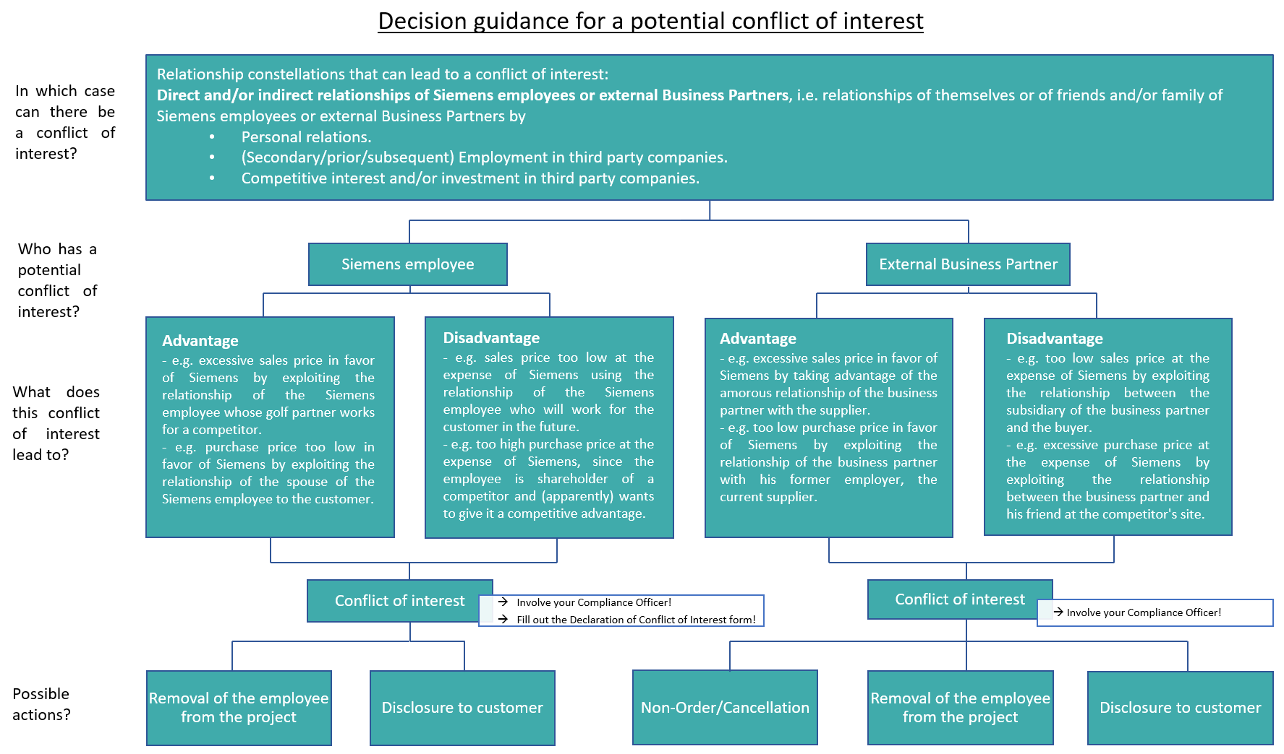 [4]

### 5.1.1. Personal relations

Close relations can lead to a conflict of interest, if business decisions are made on the basis of personal interests as a result.

Typical examples:

* There is an intimate relationship between an employee and a manager and the manager grants an undue advantage to the employee due to the personal relationship. In this case, the manager is obliged to disclose the conflict of interest at an early stage and to eliminate it by e.g. changing the reporting relationships.
* There is a recommendation of a good friend for a job at Siemens or that the Siemens employee concludes a contract with a specific supplier, in whose company a close relative or good friend of the Siemens employee works.

Both of the examples and similar situations can be solved by creating transparency.

We must adhere to the following:

* We have to inform the HR department and follow the regular processes without offering exceptions what so ever.

### 5.1.2. Relations to third-party companies: Competition with Siemens

A conflict of interest may also arise in business relationships with or through investments in a competitor or customer of Siemens. See also A.5.1.3. and A.5.1.4.

Typical examples:

* The employee also works for or advises a competitor of Siemens.
* The employee himself competes directly with Siemens (by offering products that Siemens sells).
* There are personal or family ties to competitors.

We must adhere to the following:

* We do not operate or work for a company that competes with Siemens.
* We do not engage in any activity that competes with Siemens.

### 5.1.3. Relations to third-party companies: Investment

Conflicts of interest can also arise in the case of direct or indirect investments in third-party companies or other forms of influence on a company.

For **Business partners** of Siemens that only applies if Siemens is engaged in business with the respective company or has a mandate there. In the case of investments in publicly traded companies, this only applies if the investment exceeds three percent of the total capital.

For **competitors** the above applies if the management of the competitor can be influenced through the investment. This can be assumed if the interest exceeds three percent of the total capital of this company.

A conflict of interest may also arise in business relationships with or through investments in a competitor or customer of Siemens.

Typical examples:

* The employee also works for or advises a competitor of Siemens.
* The employee himself offers products that Siemens sells.
* There are personal or family ties to competitors.
* the offer of a seat on the supervisory board of another organization. The third-party company might be a Business Partner or a competitor of Siemens. These activities require Siemens’ approval.

We must adhere to the following:

* We inform the Human Resources department in writing of any direct or indirect investment in companies:
  + That are business partners of Siemens if We are engaged in business with the company or have a board or management role in the company. With respect to publicly traded companies, this only applies if the investment exceeds three percent of the total capital.
  + That compete with our company if We can influence the management of the competitor through this investment. This is presumed if the interest exceeds three percent of the total capital of the company.

### 5.1.4. Employment: Secondary, prior or subsequent employment

A conflict may arise in the performance of secondary activities or employment, which prevent the employee from properly performing his duties at Siemens.

Secondary employment can only be prohibited, and previously granted permission only be revoked, if it leads to an impairment of the employee’s work performance, interferes with his or her duties within the company, or if there is a risk of a conflict of interest. Occasional writing, lecturing, and similar activities, and temporary seasonal or clerical work are not regarded as secondary employment.

Typical examples:

* The employee could have an accident at work due to being overtired and exhausted by his secondary employment. Therefore, such a secondary employment must be approved by Siemens.

But: Only occasional writing activities, lectures, and similar occasional activities as well as temporary work are not regarded as secondary employment.

* A prior or subsequent employment on the other hand can for example lead to the disclosure of confidential information or business secrets, if the employee does not handle the situation with care.

We must adhere to the following:

* Before we engage in paid secondary employment, we consult with our managers.
* We inform the HR department in writing that we would like to take up paid secondary employment and will only do so after obtaining written consent.

### 5.1.5. Employment: Job rotation public/private sector

A conflict of interest can also arise if employees of a company switch to the public sector or vice versa. The fast or repeated change between the public service (politics/ ministries) and the private sector may in particular lead to conflicts of interest, e.g. to influence on the legislation through the use of insider knowledge and acquired contacts.

"Waiting periods", i.e. a waiting period between the change of positions, are intended to remedy this situation. In this context, the so-called Karenzzeitengesetz (“waiting period act”) has been introduced in Germany in 2015, but other countries also have corresponding laws and regulations.

For Siemens employees but also for Siemens itself, different risks may arise in connection with the change of public servants to the private sector and vice versa. Thereby it makes no difference whether Siemens employees move to the public sector or vice versa or whether they do so temporarily as part of exchange programs or for an indefinite period of time.

We must adhere to the following:

* Thorough subject and environment check (previous activity - planned position) especially of former or current contacts to Siemens (e.g. in the context of award procedures) in order to avoid conflicts of interest.
* Transparent selection process.
* Clear and transparent documentation of the secondment.
* Examination and maintenance of legal requirements (e.g. Sec. 105 Federal Civil Servants Act (Bundesbeamtengesetz), laws on waiting periods, etc.); in this respect, if necessary, also obtain a confirmation that the hiring does not conflict with statutory, contractual or other legal obstacles and waiting period regulations from the previous function.

The following measures should be taken:

* If necessary, implementation of further internal security measures (e.g. circular).
* Limitation of secondment time (generally up to six months; in justified individual cases prolongation possible).
* No assignment to drafting bills, to executive functions or to those with final decision-making authority, to the awarding of public contracts and to functions whose exercise directly affects the specific business interests of the sending office.
* For inquiries on lobbying topics, the Siemens communication principles must be observed.

Therefore, always involve GM and CM, respectively, and please coordinate potential reactions with GM GA EU and LC C GF.

In case of doubt please refer to your Compliance Officer or to Compliance Legal (LC CO RFC LF).

#### 5.1.5.1 Specific legislation – Germany

Karenzzeitengesetz:

* Waiting period for retiring members of the Federal Government as well as for parliament state secretaries to prevent conflicts of interest between the public service contract and employment after office.
* Obligation to notify the Federal Government or its responsible member in the event of the intention to take up employment outside the public sector within the first 18 months after leaving office.
* Possibility of prohibiting intended employment in case of possible interference with public interests.
* Limitation of the prohibition period to 12 to a maximum of 18 months, Sec. 6a of the Federal Ministerial Act (Bundesministergesetz “BMinG”)
* In addition, partly own waiting period regulations at Federal State level.

Further regulations

* Obligation to maintain confidentiality on matters that have become known in office, e.g. in accordance with Sec. 6 of the Federal Ministerial Act (Bundesministergesetz “BMinG”).
* Duty to disclose a new lobbying activity for up to five years after leaving office for civil servants (judges, etc.), if the new activity is related to the previous activity. The administrative authority can then prohibit the new activity. Anyone who disregards this prohibition loses his pension rights, Sec. 105 Federal Civil Servants Act (Bundesbeamtengesetz “BBG”).
* In the extreme case, possibly criminal acceptance of benefits (Sec. 331 German Criminal Code).
* Even if the legally required waiting periods are adhered to, Sec. 331 et seq. of the German Criminal Code and the Siemens BCGs are to be observed.

Important: An employment may not be offered or granted "in return" for the performance of the service. Already the appearance of dishonesty is to be avoided.

#### 5.1.5.2 Specific legislation - others

European Union

* Members of the European Commission must notify the Commission of any intended professional activity which is to commence within 18 months after leaving the office.
* Lobbying in former departments is completely prohibited during this time.
* Furthermore, the Commissioners are subject to a non-competition clause: if there could be conflicts of interest with the former area of responsibility, an ethics committee decides on compatibility.
* For other employees in EU-Institutions, a similar waiting period of up to three years applies.

Czech Republic

* The permission to take up a position in the public service must be granted by the employer; the employment must not be terminated. However, there is no entitlement to remuneration during the exercise of the public office.
* After giving up/ leaving the public office, the employee has the right to continue working in a position of equal rank. The only exception would be the removal of the position in the meantime. If the employee is employed at a lower position, he would have to be fully compensated.
* Confidential information obtained during affiliation with the company or the public employer may not be taken into account at the other office.

USA

* Waiting periods for mandate holders and staff members of the executive range from one year to up to a lifelong ban on certain activities.
* For the legislative, a different waiting period of one up to two years applies.

## 5.2. Dos and Don’ts

To protect ourselves and our company, we pay close attention to possible conflicts of interest. The following questions help us to assess whether this is the case:

* Is the decision I make for Siemens influenced by personal interests?
* What impression does the situation leave on external third parties, such as customers, authorities, and investors?
* How would the public react to my business decision?

We must adhere to the following:

1. In case of **competition** with Siemens (For details please refer to A.5.1.2.):

* We do not operate or work for a company that competes with Siemens.
* We do not engage in any activity that competes with Siemens.

1. In case of **secondary, prior or subsequent employment** (For details please refer to A.5.1.4.)

* Before we engage in paid secondary employment, we consult with our managers.
* We inform the Human Resources department in writing that we would like to take up paid secondary employment and will only do so after obtaining written consent.

1. In case of **investment in third-party companies** (For details please refer to A.5.1.3.):

* We inform the Human Resources department in writing of any direct or indirect investment in companies:
  + That are business partners of Siemens if We are engaged in business with the company or have a board or management role in the company. With respect to publicly traded companies, this only applies if the investment exceeds three percent of the total capital.
  + That compete with our company if We can influence the management of the competitor through this investment. This is presumed if the interest exceeds three percent of the total capital of the company.

1. In case of **close relations** (For details please refer to A.5.1.1.)

* We have to inform the HR department and follow the regular processes without offering exceptions what so ever.

1. In case of **job rotation public/private sector** (For details please refer to A.5.1.5.)

* Thorough subject and environment check (previous activity - planned position) especially of former or current contacts to Siemens (e.g. in the context of award procedures) in order to avoid conflicts of interest.
* Transparent selection process.
* Clear and transparent documentation of the secondment.
* Examination and maintenance of legal requirements (e.g. Sec. 105 Federal Civil Servants Act (Bundesbeamtengesetz), laws on waiting periods, etc.); in this respect, if necessary, also obtain a confirmation that the hiring does not conflict with statutory, contractual or other legal obstacles and waiting period regulations from the previous function.

The following regulations should be taken:

* If necessary, implementation of further internal security measures (e.g. circular).
* Limitation of secondment time (generally up to six months; in justified individual cases prolongation possible).
* No assignment to drafting bills, to executive functions or to those with final decision-making authority, to the awarding of public contracts and to functions whose exercise directly affects the specific business interests of the sending office.
* For inquiries on lobbying topics, the Siemens communication principles must be observed.

## 5.3. Training and supporting material

Detailed public information can also be found here:

* [ICC Guidelines on Conflict of Interest in Enterprises](https://icc-estonia.ee/wp-content/uploads/2018/06/ICC-Guidelines-on-CoI-and-Dilemmas-final-4-5-18.pdf)
* [OECD Guidelines for Managing Conflict of Interest in the Public Service](http://www.oecd.org/gov/ethics/oecdguidelinesformanagingconflictofinterestinthepublicservice.htm)

Siemens internal information can be found here:

* Presentation: [“Siemens and the public sector - The change of employees between the public service and the private sector”](https://findit.compliance.siemens.com/content/10000101/Compliance/LC_CO/LC_CO_RG_PL/findIT_LC_CO_RG_PL_7244.pdf)
* Article in the news center: “[What is allowed, what is prohibited](https://newscenter.siemens.com/siemens-news/index.php?webcode=50076487&rwlogin=1)?”
* [Intranet Page BT HQ Switzerland „Sideline Work“](https://intranet.for.siemens.com/cms/080/en/processes/collaboration/Pages/hr-experts.aspx)
* [Conflict of interest BCG short film](https://myvideo.siemens.com/media/1_cadb24vv)
* Potential sample for declaration form: [Conflict of Interest](https://findit.compliance.siemens.com/content/10000101/Compliance/LC_CO/LC_CO_RG/findIT_LC_CO_RG_7994.docx)

## 5.4. History of changes

|  |  |  |
| --- | --- | --- |
| **Date** | **Author** | **Major changes of binding content** |
| January 1, 2019 | Christina Wolfgramm | Wording and structure in line with the new Business Conduct Guidelines. First release through the Compliance Handbook. |
| January 1, 2020 | Koen Miezenbeek | Update due to organizational changes |

## 5.5. Contacts

Compliance Officer

The Compliance Officer responsible for your unit can be found through the following [link](https://intranet.for.siemens.com/cms/059/en/about/org/Pages/compliance_organization.aspx).

Corporate Governance Owner

The contact persons for conflicts of interest are:

Christina Wolfgramm (LC CO RFC LF)

Ulrike Desimoni (LC CO RFC LF)

1. To do so, please use the [Declaration form: Conflict of Interest](https://findit.compliance.siemens.com/content/10000101/Compliance/LC_CO/LC_CO_RG/findIT_LC_CO_RG_7994.docx).
2. External Business Partner: see [A.](https://workspace.c6.siemens.com/content/300000007/Compliance%20WebBook/Part%201%20Activity%20Fields/A)%20Anti-corruption/4.%20Business%20Partners.docx)4.
3. Third-party: Customer (e.g. public sector), Supplier, Competitor.
4. The Declaration of Conflict of Interest form can be found [here](https://findit.compliance.siemens.com/content/10000101/Compliance/LC_CO/LC_CO_RG/findIT_LC_CO_RG_7994.docx).